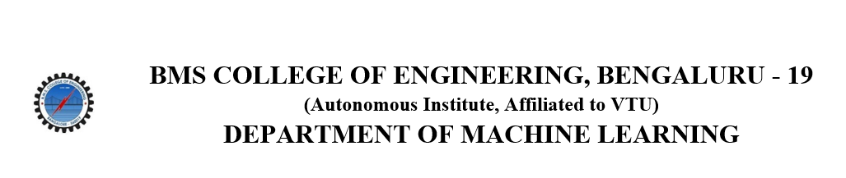
ACTIVITY REPORT
On

DSA COURSE
- Name of the club: BMSCE ACM STUDENT CHAPTER
- Name of the Activity: DATA STRUCTURES AND ALGORITHMS(DSA) COURSE
- Objectives: The BMSCE ACM Student Chapter organized a course on
“Data Structures and Algorithms”. This workshop aimed to provide insights into fundamental data structures, algorithm design, and their applications.
- Date, Time Venue of the Activity:
Resource Person | Abhinav Kumar, Skylark Drones
TOPIC | DATA STRUCTURES AND ALGORITHMS
DATE/DAY | Sunday, 21st January 2024
MODE | ONLINE
DURATION | 12 Weeks
- Name and details of collaborating agency (if it is collaborative/joint activity): N.A
- Brief summary of the Programme: The Data Structures and Algorithms (DSA) course, starting on January 21, spans over three months and is meticulously designed for beginners aiming to excel in technical interviews. Conducted online, this comprehensive program offers a robust curriculum covering essential concepts in Java and C++. With a registration fee of ₹300, participants are provided with a thorough grounding in DSA, guided by expert instructor Abhinav Kumar from Skylark Drones. His extensive experience in data structures and algorithms ensures that learners receive top-notch education and practical insights. Sudeep and Harsha, as event coordinators, have played pivotal roles in orchestrating this course, seamlessly ensuring its success.
Each week of the course delves into specific topics, beginning with foundational concepts such as Time Complexity, Pointers, and Searching Techniques. As the course progresses, participants explore a variety of critical subjects including Arrays, Strings, Sorting Techniques, Linked Lists, Stacks, Queues, Recursion, and Trees. Advanced topics such as Heap Tree, Hashing, Graphs, Dynamic Programming, Greedy Algorithms, Backtracking, and Bit Manipulation are also comprehensively covered. The final weeks include mock interviews and reviews, ensuring that participants are well-prepared for real-world technical challenges.
The teaching methodology employed in the course is highly interactive and practical. Weekly lectures are designed to be comprehensive, fostering an engaging learning environment. Hands-on coding problems and practical exercises help reinforce theoretical knowledge. Participants have access to valuable resources including lecture notes, reference guides, and practice problems, enhancing their learning experience. Weekly Q&A sessions provide an opportunity for interactive discussions, allowing learners to clarify doubts and deepen their understanding. The positive feedback from participants highlights the effectiveness of this approach, appreciating the course structure and the instructor’s expertise.

- Outcomes: The course proved invaluable, providing deep insights into computer science fundamentals, empowering participants to craft efficient data structures and algorithms. Additionally, it sharpened their problem-solving prowess, equipping them for competitive programming and technical interviews.
- Number of participants:
Number of Faculty | Number of  Non-Teaching Staff | Number of  External Participants | Number of Students
0 | 0 | 8 | 33

- Two or three relevant Photographs of the activity: (Geo-tagged photos are preferable)
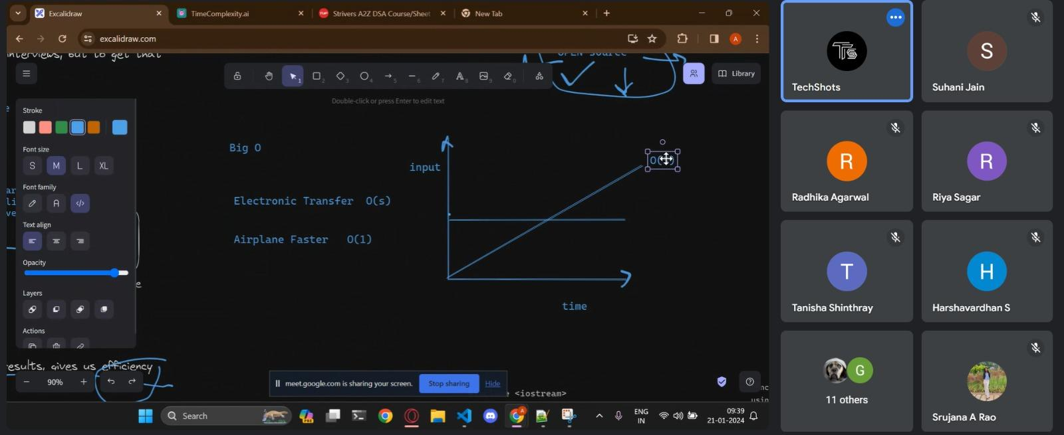

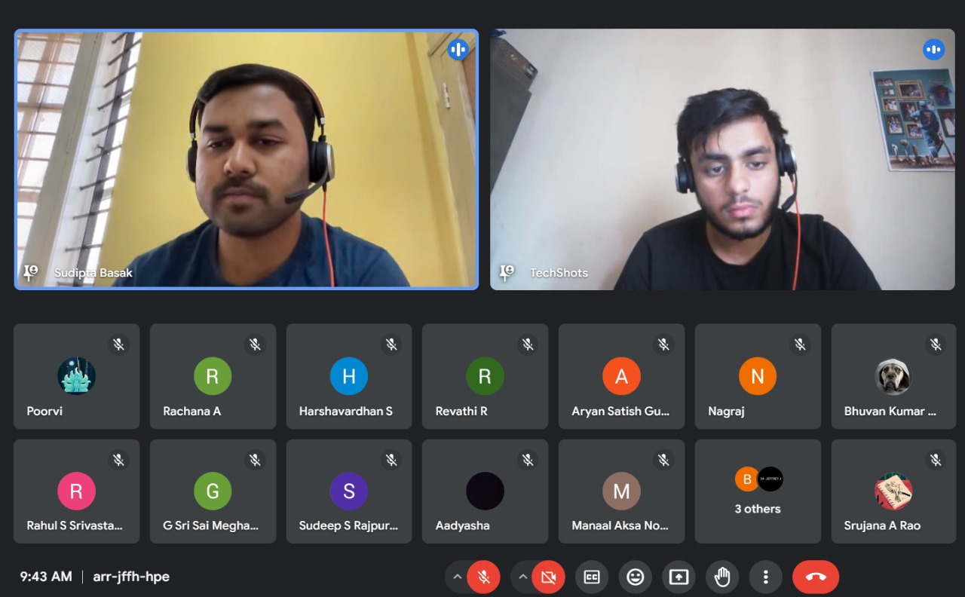

Supporting Documents
a) Attendance sheet
b) Circulars/Brochures
c) Certificates

